CS4163 - Advanced Networking, Virtualization and Cloud Computing
Practical ICA – (Assessment) 01
Task - 04 Failover and Redundancy

01.Network Topology Overview
- Switches:
  - S1: Connected to PC1 (192.168.10.10, VLAN 10) and PC2 (192.168.20.10, VLAN 20), linked to S5 and S8.
  - S2: Connected to PC3 (192.168.10.11, VLAN 10) and PC4 (192.168.20.11, VLAN 20), linked to S5 and S8.
  - S3: Connected to PC5 (192.168.30.10, VLAN 10) and PC6 (192.168.40.10, VLAN 20), linked to S6 and S7.
  - S4: Connected to PC7 (192.168.50.10, VLAN 10) and PC8 (192.168.60.10, VLAN 20), linked to S7 and S6.
  - S5: Distribution switch connecting S1, S2, and R1, linked to S8.
  - S6: Distribution switch connecting S3, S4, and R2, linked to S7 and S8.
  - S7: Distribution switch connecting S3, S4, and R2, linked to S6 and S8.
  - S8 (Newly Added): Secondary distribution switch connecting to S5, S6, S7, S1, and S2.
- Connections for S8 (Newly added):
  - S8 to S5: FastEthernet0/3 on S8 (trunk link, VLAN 10 and 20).
  - S8 to S6: FastEthernet0/4 on S8 (trunk link, VLAN 10 and 20).
  - S8 to S7: FastEthernet0/5 on S8 (trunk link, VLAN 10 and 20).
  - S8 to S1: FastEthernet0/6 on S8 (trunk link, VLAN 10 and 20).
  - S8 to S2: FastEthernet0/7 on S8 (trunk link, VLAN 10 and 20).

02.Verify STP Status (Before Failure)
On S5 (Root for VLAN 10):
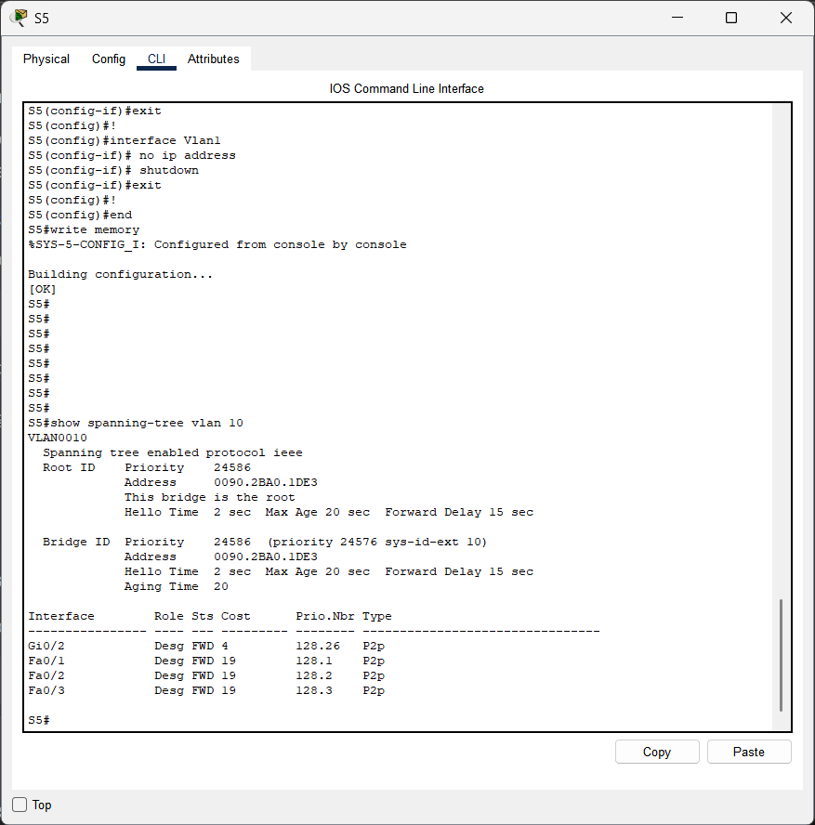
Observation: S5 is the root bridge for VLAN 10.
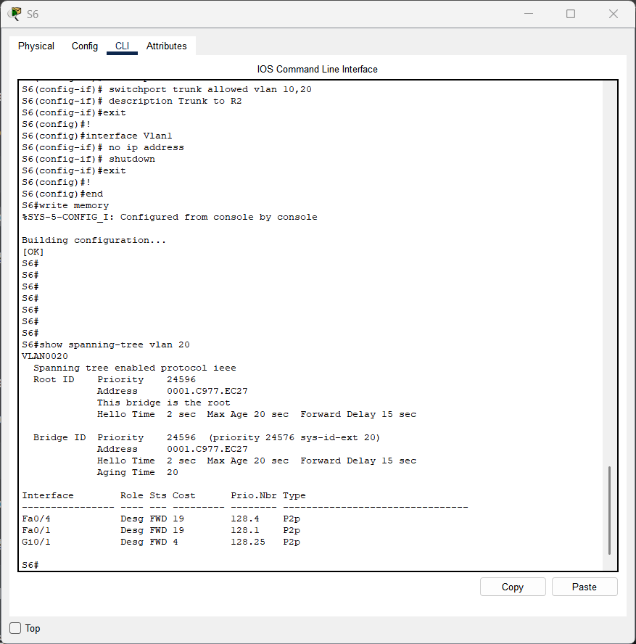
On S6 (Root for VLAN 20):

Observation S6 is the root bridge for VLAN 20.

On S1 (Check Blocked Ports):
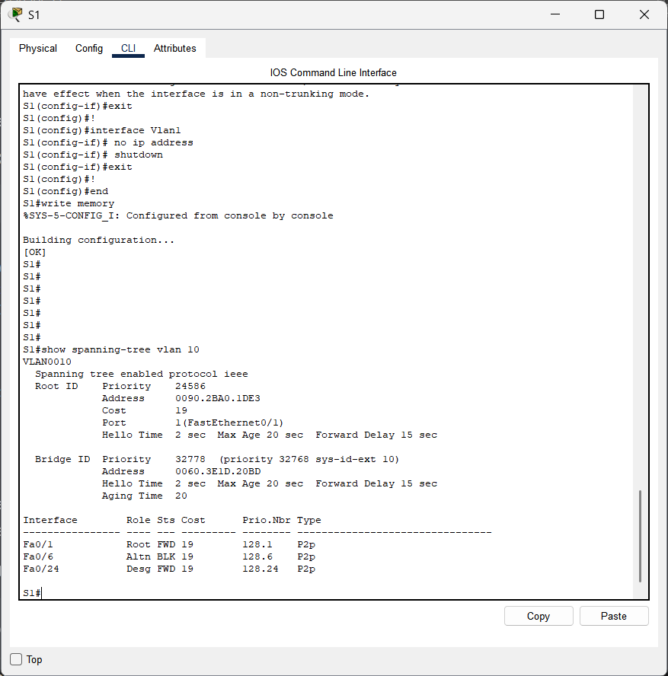

Observation: S1’s Fa0/1 (to S5) is forwarding, and Fa0/6 (to S8) is blocked for VLAN 10, preventing loops.
03.Test Connectivity (Before Failure)
• Test 1: Ping from PC1 (192.168.10.10, VLAN 10) to PC5 (192.168.30.10, VLAN 10).
- Command: ping 192.168.30.10 from PC1.
- Result: Success (path: S1 → S5 → R1 → S6 → S3).
- Screenshot:
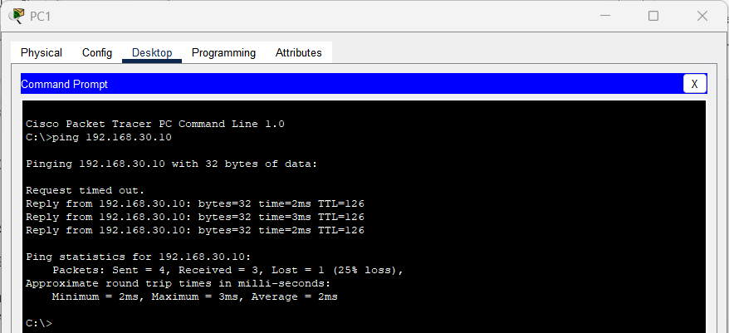

• Test 2: Ping from PC2 (192.168.20.10, VLAN 20) to PC6 (192.168.40.10, VLAN 20).
- Command: ping 192.168.40.10 from PC2.
- Result: Success (path: S1 → S5 → R1 → S6 → S3).
- Screenshot:
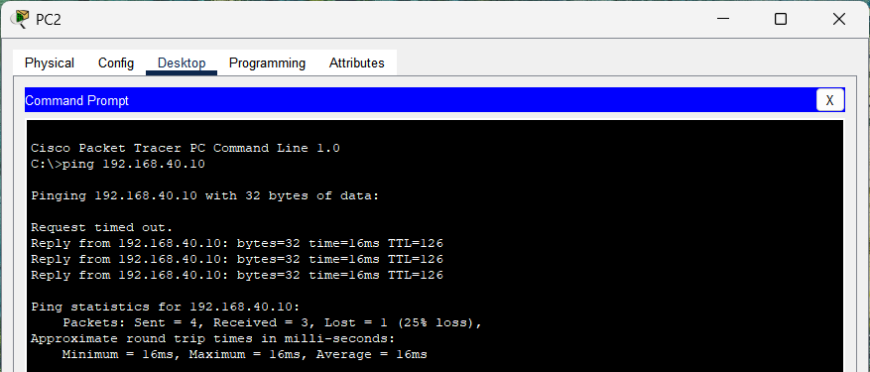

04.Simulate Switch Failure (S5 Failure)
Simulate a failure by shutting down S5’s key interfaces (links to S1, S2, S8, and R1).
- On S5:
enable
configure terminal
interface FastEthernet0/1
shutdown
interface FastEthernet0/2
shutdown
interface FastEthernet0/3
shutdown
interface FastEthernet0/4
shutdown
end

Effect: This simulates a complete failure of S5, disconnecting S1 and S2 from their primary path to the network.

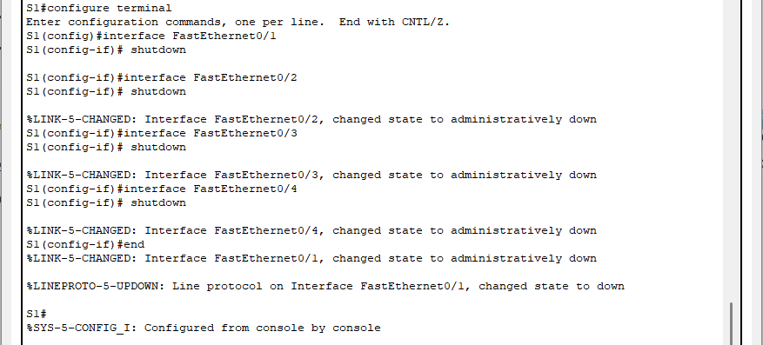
- Screenshot:

05.Verify STP Status (After Failure)
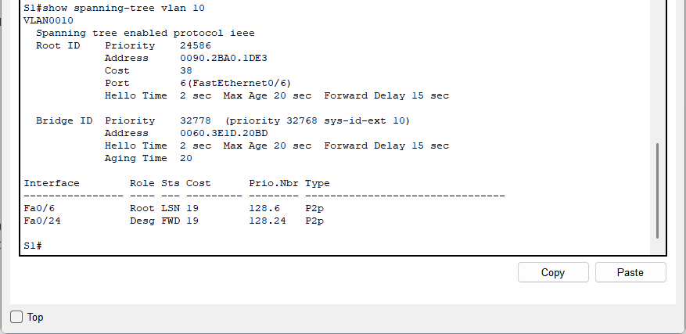
On S1:

Observation: After S5 failure, S1’s Fa0/1 (to S5) is down, and Fa0/24 (to S8) becomes the forwarding port, with S8 as the new root path for VLAN 10.

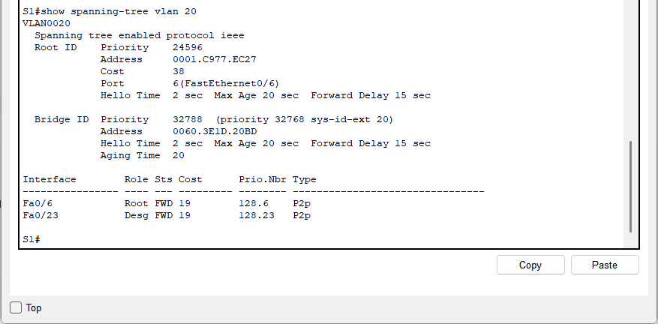
On S1 for VLAN 20:

Observation: For VLAN 20, S1 now forwards traffic through S8 to reach S6 (the root for VLAN 20).

06.Test Connectivity (After Failure)
• Test 2: Ping from PC2 (192.168.20.10, VLAN 20) to PC6 (192.168.40.10, VLAN 20).
- Command: ping 192.168.40.10 from PC2.
- Result: Success (path: S1 → S8 → S6 → S3).
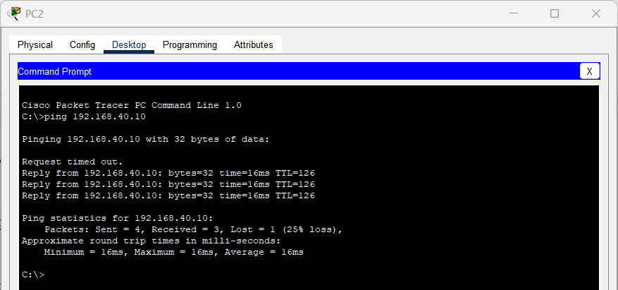
- Screenshot:

07.Document Failover Mechanism
Detailed Notes on STP Failover
- STP Overview: Spanning Tree Protocol (STP) prevents loops in a network with redundant links by blocking certain ports while keeping others in a forwarding state. Per-VLAN Spanning Tree (PVST) allows separate STP instances for each VLAN, optimizing paths per VLAN.

- Configuration Details:
  - S5 is the root bridge for VLAN 10 (spanning-tree vlan 10 root primary).
  - S6 is the root bridge for VLAN 20 (spanning-tree vlan 20 root primary).
  - Redundant links (e.g., S1 to S5 and S8) create loops, which STP manages by blocking ports (e.g., S1’s Fa0/2 to S8 is blocked under normal conditions).

- Failover Process:
  - Under normal conditions, S1 forwards traffic through S5 (root for VLAN 10) and blocks the link to S8.
  - When S5 fails, STP reconverges (typically within 30-50 seconds for PVST):
    - S1 detects the loss of the root path through S5.
    - S1 unblocks Fa0/2 (to S8) and recalculates the path to the new root (S8 for VLAN 10, S6 for VLAN 20 via S8).
  - Traffic is rerouted automatically through S8, ensuring continuity.

- Recovery:
  - When S5 is brought back online, STP reconverges again, and S5 resumes its role as the root bridge for VLAN 10, potentially blocking S1’s link to S8 again.

